**Note:** Create the tables as indicated in Read Me for Search Help Demos.doc.

Proceed with the below steps only after that.

1. Create an Elementary search help in SE11.

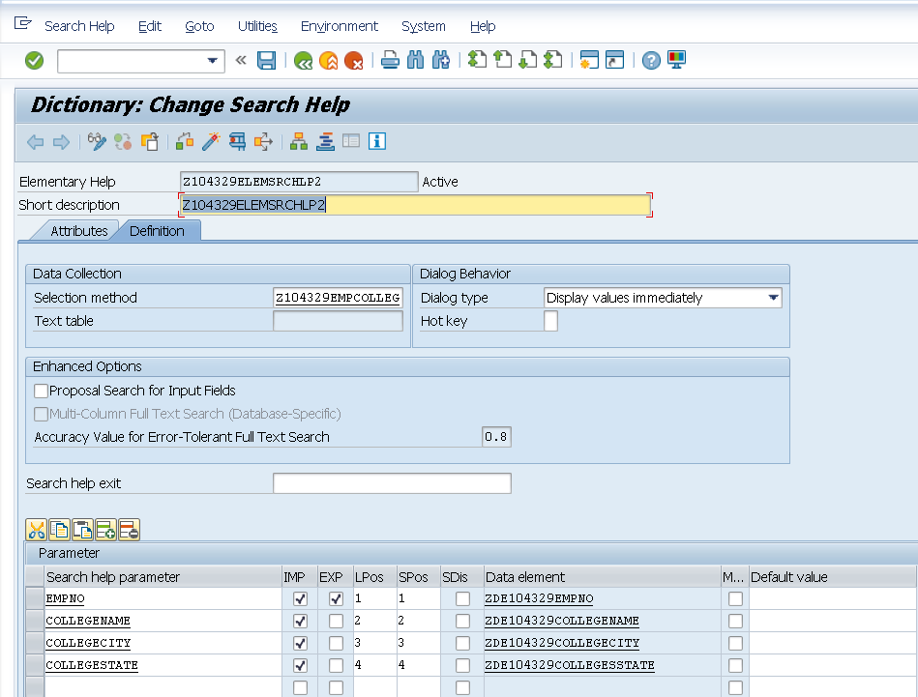

1. Test the search help.
2. Note the Import parameters.
3. Note the Export Parameter.
4. **Delete the earlier search help assigned to the field Empno.**
5. Attach the elementary search help to the DB table Emp.

In this case search help is attached to Empno field.

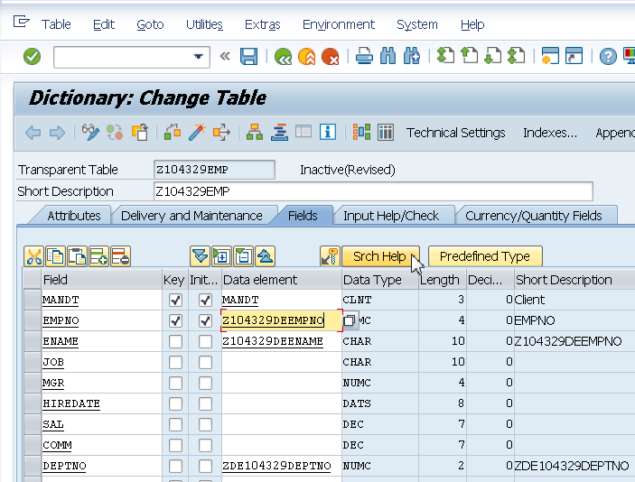

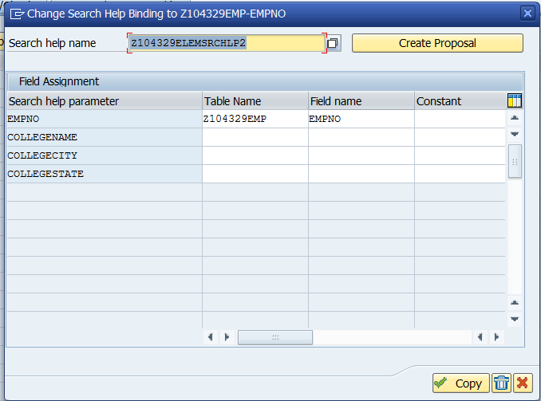

1. Create entries in the DB table.

Observe search help while adding records in the Empno field of the Emp table.

Note: In this case there is a TMG associated with the table Emp.

Hence search help is visible as below.

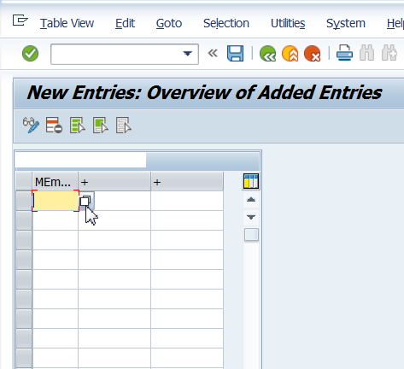

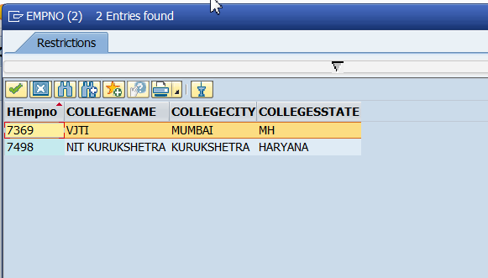

Select 7369.

